A Multi-Tenant SaaS Framework for Online Retail Systems
Aryan Goud
Dept. of Computer Engineering
Thakur College of Engineering And Technology
Mumbai, India
1032230214@tcetmumbai.in
Akshata Raut
Dept. of Computer Engineering
Thakur College of Engineering And Technology
Mumbai, India
akshata.raut@tcetmumbai.in
Gaurav Gautam
Dept. of Computer Engineering
Thakur College of Engineering And Technology
Mumbai, India
1032230210@tcetmumbai.in

Nidhay Chavan
Dept. of Computer Engineering
Thakur College of Engineering And Technology
Mumbai, India
1032230186@tcetmumbai.in

Abstract— Small and micro-scale organizations often challenge an architectural and economic cutoff in their effort to enter digital retail markets: that the basic cost model of conventional services is front-loaded, with procurement or licensing of software, customization and integration, maintenance and monotonous operational costs all in the fore. This is a predominantly punishing kind of fixed-cost disclosure on vendors having low initial capital and ambiguous demand, creating an adoption irregularity in which only adequately capitalized actors can safely proceed to digitalize. Multi-tenant surveys have formerly shown that all of them can attain per-tenant cost firmness through resource pooling, and sustain logical separation of tenant data and configurations. Based on these assets, the current paper proposes a multi-tenant SaaS architecture that implements a monetization business model of a "commission-only" nature: the platform will record income as a flexible percentage of the transactions made, which is found in the literature as aspects of chained-payment systems separating proceeds between the vendor and the provider. Architecturally, the proposed framework contains (i) shared- schema multi- tenancy and explicit enforcement of tenant context to moderate the risk of cross- tenant leakage recognized in shared data models (ii) a template-injection front-end engine where tenant storefronts are formed out of persisted layout schemas instead of targeted code and (iii) domain-based request resolution over subdomain routing patterns as defined over SaaS publishing workflows. The resultant system has been placed as a cost-aligned, pay by grow dynamo of small vendors, with the delivery logistics specifically decoupled in the implementation- vendor managed, with order completion modelling literature, and tenancy operation.
Keywords— Multi-tenancy, SaaS architecture, monetization business, domain resolution, template injection, commission-based platform modeling.

Introduction
Authorising digital retail has often been framed as a technical challenge, but for sellers with restricted capital it is equivalently an economic one. The key driver in a multi-tenant retail system intended at small and medium enterprises is not simply feature accessibility but the total cost envelope – development, customisation, training, maintenance, and the ongoing operational load of running and upgrading infrastructure [1], [2]. The cost taxonomy observed in the literature (upfront investment, recurring divestment-type costs, and continuous operational costs) builds a condition where merchants are hit with fixed liabilities before their first sale ever occurs, discouraging startups and small ventures. Multi-tenancy is frequently cited as a tool that lowers operational expense by letting tenants share applications and infrastructure while keeping their data logically isolated [1], [9]. The implication is both architectural – the platform can be formed as a shared resource layer – and economic – pricing can be tied to usage rather than to a fixed subscription.
The economic structure that drives the framework in this paper is a “commission-only” revenue model. Transaction-based pricing has existed in earlier multi-tenant retail proposals where merchants pay only when an order is received; these have been implemented as a percentage deduction at payment time (e.g., a fixed fraction transferred to the provider). The proposed framework simplifies this idea across a configurable commission band (for example 5–10%), realised through a payment-splitting algorithm, so that platform income rises only when tenants earn revenue. Conceptually, this mirrors the “payment-on-order” logic already discussed in the literature [1].

Literature survey
- overview of key findings from literature review
Sr.No. | Title | Gaps | Findings
1 | SaaS based Multi-tenant E-commerce to reduce cost and improve resource utilization | Focuses on general cost reduction; lacks specific domain mapping for B2B sub-tenants. | Multi-tenancy reduces development and maintenance costs by sharing codebases.
2 | Multi-Tenant Architecture: A Comprehensive Framework for Building Scalable SaaS Applications | Theoretical framework; lacks specific implementation for commission-based retail models. | Defines isolation strategies (database vs. schema) for scalable SaaS.
3 | A Multi-Vendor Saas website builder with Role-Based CRM | Focuses on marketing agencies; does not detail the commission-split payment flow. | Discusses "all-in-one" platforms with integrated CRM and visual builders.
4 | Multi-Tenant SaaS Architectures: Design Principles and Security Considerations | Heavy focus on security/compliance; less focus on frontend template customization | Compares single-tenant vs. multi-tenant database partitioning strategies.
5 | Towards Dynamic Tenant Management for Microservice based Multi-Tenant SaaS Applications | Does not integrate storefront, domain resolution, or transaction commissions | Proposes a methodological framework to manage tenancy degree in microservice-based SaaS
6 | Ensuring Highperformance of Mission-critical Java Applications in Multi-tenant Cloud Platforms | Concentrates on backend performance interference; does not address retail specific concerns such as storefront templating or commission settlement. | Identifies multi-tenant performance pathologies for Java workloads on shared platforms and emphasizes the need for isolation against adverse cross-tenant effects.
7 | Multi-Tenant Ecommerce based on SaaS Model to Minimize IT Cost | Limited attention to advanced isolation governance and generalized domain strategies. | Argues multi-tenant retail SaaS reduces IT cost for vendors and supports per-order/usage-contingent charging, reinforcing transactions-based affordability for small enterprises.
8 | Cloud Based ECommerce Platform for Multi-Tenant and Multi-Vendor | Assumes a cloud stack; not focused on template storefront UX. | Proposes multi-tenant PaaS with REST APIs and cloud workflow; includes tenant tables and architecture diagrams.
9 | A Systematic Mapping Study on the Multi-tenant Architecture of SaaS Systems | A survey paper; does not propose a specific architectural solution for retail. | Identifies customization and migration as major challenges in SaaS.
10 | Thread-level resource consumption control of tenant custom code in a shared JVM for multi-tenant SaaS | Deep JVM-level solution space; does not address tenant facing retail concerns | Proposes controlling CPU/memory at the thread level for tenant code.
11 | A Decision-based Model for Optimizing the Deployment of Cloud-hosted Application Components to Guarantee Multitenancy Isolation | Decision modeling does not materialize as a full retail SaaS stack; commission economics absent | Presents a model balancing degrees of component isolation against resource consumption and performance impact, supporting isolation-aware deployment decisions.
12 | Transforming ECommerce Platforms through Multi-Tenant Architectures and Microservices | Storefront templating is not central. | Examines transforming retail platforms using multi-tenant architectures and microservices to address scalability and reliability demands.

METHODOLGY
The proposed framework is formed as a multi-tenant engine that facilities the burden of vendor-entry fixed costs by concentrating engineering effort on a single codebase and a shared operating substrate. This is consistent with multi-tenant SaaS cost arguments: several tenants use common infrastructure, but are logically isolated [8], [9], [12]. The design choices are classified into (i) data architecture, (ii) design of the presentation layer, domain-specific request routing, and (iv) settlement logic. The system is not intended to be logistics; order and shipment are still the responsibility of the responsibility of each tenant, in models such as the merchant ships after payment.

Monetization logic via commission settlement at payment time.
Management of commission-based monetisation as an architectural prerequisite rather than a mere billing afterthought has clear precedent. A fixed percentage of each purchase can be deducted during payment, so that the end-user pays a single amount and the payment service divides the funds between tenant and provider.
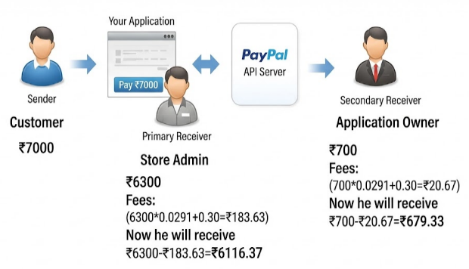

- Chained payment in the proposed system
The protocol extends this to a variable commission parameter within a range. Operationally:
∙ At payment time the payment request is for two recipients: the tenant and the provider.
∙ When the payment is captured, the platform provider’s share (commission × amount) and the tenant’s share (1 - commission) x amount) and triggers a split settlement.
∙ The split is recorded and tenant’s order status via callbacks (webhooks) from the gateway, as the event-driven synchronization patterns used for payment systems in multi-tenant SaaS solutions.

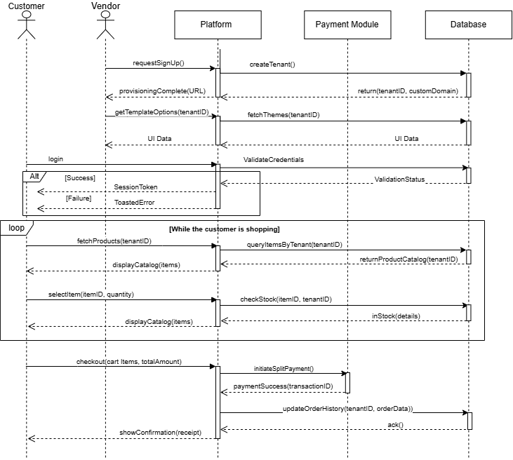

- Sequence diagram for the proposed system
Figure 2 shows the proposed system's operational project and detailing the interfaces between external and internal system components. The process begins with the seller onboarding stage, whereby the platform orchestrates the provisioning of a tenant ID and domain via the centralised database to achieve segregation. Then, the customer entry: the context aware aware login process. Using an "Alt" fragment, the diagram shows the difference between issuing a and error responses, highlighting the process of system handles secure, stable access to the system across different environments, while ensuring a standardised and solid backend structure.
The main collaboration with the storefront occurs inside a shopping shopping loop, with the system dynamically fetching and presents catalogs that are categorized by the customer’s tenant ID. This means that customers only access data from vendors, maintaining the reliability of multi tenant architecture with frequent browsing. The sentence: flow ends with a transaction phase with commission-based split payments. The platform manages funds between the vendor and provider prior to performing a synchronous update. By demanding a official response from the database before sending an order confirmation, ensuring consistency.

Shared-schema multi-tenancy and tenant isolation enforcement.

Our system uses a shared-schema approach: tenant-specific data are stored in shared tables with a discriminator (e.g., tenant identifier) which determines the scope of each operation. Although the proficiency benefits of shared-schema models are well-known, scholars also often mention a key failure mode - failure to scope a query can make one tenant's data accessible to another [3], [4]. Therefore, the technology considers tenant context as a cross-layer primitive:
∙ On entry, each request is mapped to a specific tenant ID before the business logic is invoked, forming a strong barrier (equivalent to context-based in multi-tenant scenarios).
∙ Tenant scoping is applied in the data access layer centrally rather than relying on individual discipline, as suggested by best practices for strict disciplines in collaborative models.
∙ Optionally, at the database boundary, the framework can use mitigations such as row-level policies, such as reviewed for shared data. This multi-layered approach follows security-by-design advice that treats data isolation and access control as fundamental multi-tenant requirements [4].

Template-injection front-end engine
Template-injection front-end engine an important objective is to enable tenants to build storefronts without custom development. Study about multi-tenant "all-in-one" platforms discusses today's graphic builder workflows and layout systems in which page schemas are formalized and extracted by reused by a common engine; templates can be seen as in-place templates that are copied and adapted [3]. In in the proposed method, template injection refers to a rendering pipeline where:
- For a given canonical page type (e.g., landing page, page, catalog/product views), a tenant selects one out of a few (normally 4-5) designs to maintain consistency.
- The choice is a tenant-specific page blueprint (components and layouts) stored as tenant data.
- During run time, the rendering engine generates the storefront by plugging tenant-specific content and with the chosen page schema.

This approach is an example of a "configuration first" “coding first” mindset. It is consistent with (i) multi-tenant applications that already support customization of the layout of the store time [1], and (ii) schema-based publishing workflows of multi-tenant builder systems. The carefully limited template library helps alleviate the bloat of feature-laden systems, consistently good performance at the expense of some easier maintenance under shared infrastructure [3].

Domain logic and tenant resolution.
The system must support two domain models concurrently: subdomain-based identity and custom domain identity.

Subdomain identity is immediately feasible: earlier multi-tenant e-commerce platforms allow a tenant to specify a when signing up, and it hosts a store at that subdomain. More broadly, wildcard DNS mapping - linking any subdomain to the publishing - mapping any subdomain to its SaaS publishing engine - is commonplace. Custom domain identity provides an extension by tenant-specified hostname to point to this storefront. In the literature, the emphasis is on subdomain routing [1], [3], the same architectural concepts - host-based routing and strict context propagation - apply to a “domain “alias” table indexed by hostname.
As such, the tenant-resolution algorithm follows:
- Check the incoming request for the Host header.
- If the host matches the platform’s canonical pattern, extract the tenant key from the subdomain (subdomain method).
- Else, look up the host against a domain-alias registry to the tenant ID (custom domain method) with the lookup time (with caching) - a common practice with the multi-tenant focus on performance-critical shared infrastructure [4], [6].
- Bind the resolved tenant ID to the request’s context and require it to be used to restrict all data access within the correct tenant context and enforcement must happen at every system entry point [3]. It also echoes security-oriented recommendations that tenant isolation should be upheld at all architectural layers [4].

This algorithm is conceptually in line with the "data scoping imperative” of hierarchical tenancy models, in which the core data operations are trusted in the appropriate tenant and security must occur at every entry point [3]. It also echoes security-focused recommendations that tenant isolation should be enforced throughout the system [4].

Performance isolation and multi-tenant robustness in a Java-centric implementation.
As the planned implementation language is Java, issues associated with the shared runtime problems - they are critical to tenant density. The cross-tenant effects can be extended by the interactions with the operating system and the JVM, including swapping, when tenants compete for CPU and memory, causing performance interference for multi-tenant Java environments [6].

Two complementary implications come to mind: The system should be observable at runtime and it should be protected from the “noisy neighbor” effect, which is observed in multi-tenant Java-based platforms [6]. The use of resources should be controlled at a fine grain (for example, at the thread level on a shared JVM) if tenant extensions are ever allowed to execute custom code so that the code of one tenant does not negatively affect the entire platform [10].

If the framework itself is divided internally into microservices, the tenancy management can be applied at service granularity, as is common in microservice based solutions, which differentiate between application level and microservice level multi tenancy, and deploy services dynamically to satisfy different tenant requirements [5]. In addition, decision models which explicitly consider the cost of resources at certain isolation levels can help make isolation aware decisions about deployment in the cloud for cloud-based components [11].
- Comparison among multi-tenant, multi-instance and, microservice based multi-tenant deployment approaches
Factor | Multi-tenant | Multi-instance | Hybrid (microservice based multi-tenancy)
Operational Cost | Lower | Higher | Lowest
Resources | Shared | Dedicated | Mixed
Number of instances | Manage less number of instances for a number of tenants | Manage as many instances as tenants | In-between both
Privacy | False | True | True
Isolation | Low | High | Medium
Application Design | Complex | Simpler | Most complex

In Table II, it can be seen that the hybrid microservice-based approach optimizes operational costs and privacy, offering a superior alternative to traditional shared or dedicated models. While it provides a balanced middle ground for isolation, it demands the highest level of architectural sophistication.

CONCLUSION

This paper has described a multi-tenant SaaS framework for online retail systems, based on the central argument that affordability and usability for small sellers are not merely surface-level design features but stem from how costs and risks are distributed over time. The literature on multi-tenant retail SaaS consistently points out that conventional fixed-cost overheads – development, customization, infrastructure setup, maintenance, and operational running costs – are out of reach for low-budget merchants, whereas multi-tenancy reduces these costs through shared code and shared infrastructure. The framework operationalizes this shift by making monetization transaction-dependent, with commission taken at payment time through split-settlement patterns established in multi-tenant retail pricing. Architecturally, it integrates shared-schema multi-tenancy with enforced tenant context to guard against isolation breaches in shared data models, a template-injection front-end engine that follows schema-driven multi-tenant publishing, and domain-based request resolution based on subdomain and custom domain routing patterns. The platform deliberately keeps logistics outside its scope, preserving vendor-managed fulfilment, and concentrates on the programmable core: identity, storefront creation, transaction processing, and scaling while preserving isolation.

FUTURE SCOPE
The corpus points again and again to the fact that the customization facing tenants will be oriented towards automation, that analytic intelligence will be a competitive substrate as the data of unified platforms is present.

To start with, automated storefront synthetic AI agents can be perceived as the logical continuation of a process that is more straightforward than manual template selection. Multi-tenant builder systems are already conceptualized as schema generation and rendering; therefore a generative agent may generate a valid page schema, based on natural-language constraints, and fill in component structures and copy without violating the design system inside the platform . This trend is aligned with open communication of AI-controlled component generation and schema-driven UI development in multi-tenant platform scenarios. In the case of retail tenants, these agents would act as an abstraction over template injection and take the place of extreme cognitive load but maintain the common rendering engine of the platform.

Second, analytics along with forecasting inventory intelligence comes naturally after the platform gathers event streams: page views, product interactions, shopping cart, and purchases. Such extensions (e.g. the analysis of viewed and purchased products) of analytics and recommendation logic are already foreseen in earlier multi-tenant retail work. Even more detailed multi-tenant platform descriptions also refer to cross-module analytics and predictive forecasting as a state of the art functionality made possible by integrated data formulations. In the case of the expected framework, analytics would be oriented on actionable vendor constraints: predicting stockouts, uncovering high-velocity SKUs and generating demand signals, which can be sent to vendor.

Acknowledgment

The authors acknowledge the foundational research community whose work on cloud computing, multi-tenancy, isolation, and performance engineering enabled the synthesis of this framework and its architectural positioning across security, scalability, and economic constraints.

References
- F. Shaikh and D. Patil, "SaaS based Multi-tenant E-commerce to reduce cost and improve resource utilization," 2015 IEEE 9th International Conference on Intelligent Systems and Control (ISCO), Coimbatore, India, 2015, pp. 1-6, doi: 10.1109/ISCO.2015.7282302.
- Pushpan, Shinu. (2024). Multi-Tenant Architecture: A Comprehensive Framework for Building Scalable SaaS Applications. International Journal of Scientific Research in Computer Science, Engineering and Information Technology. 10. 1117-1126. 10.32628/CSEIT241061151.
- Rathod, Rohit & Londhe, Omkar & Waghmare, Harshad & Varande, Ajay & Khedikar, Sarita. (2025). A Multi-Vendor Saas website builder with Role-Based CRM. K. Elissa, “Title of paper if known,” unpublished.
- Kumar, Ritesh. (2020). Multi-Tenant SaaS Architectures: Design Principles and Security Considerations. 5. 49-62. 10.35629/8193-05024962.
- Sumit Kalra and T. V. Prabhakar. 2018. Towards Dynamic Tenant Management for Microservice based Multi-Tenant SaaS Applications. In Proceedings of the 11th Innovations in Software Engineering Conference (ISEC '18). Association for Computing Machinery, New York, NY, USA, Article 12, 1–5. doi: 10.1145/3172871.3172882M.
- Z. Zhuang, C. Tran, H. Ramachandra and B. Sridharan, "Ensuring High-Performance of Mission-Critical Java Applications in Multi-tenant Cloud Platforms," 2014 IEEE 7th International Conference on Cloud Computing, Anchorage, AK, USA, 2014, pp. 618-626, doi: 10.1109/CLOUD.2014.88.
- F. Shaikh and D. Patil, "Multi-tenant e-commerce based on SaaS model to minimize IT cost," 2014 International Conference on Advances in Engineering & Technology Research (ICAETR - 2014), Unnao, India, 2014, pp. 1-4, doi: 10.1109/ICAETR.2014.7012861.
- C. Bemagoni and S. B. Kare, “Cloud Based E-Commerce Platform for Multi-Tenant and Multi-Vendor,” International Journal of Engineering Research & Technology (IJERT), vol. 3, no. 9, pp. 96–99, Sept. 2014, Art. no. IJERTV3IS090134.
- Pinto, Hugo & Luz, J & Ramos de Oliveira, Ricardo & Lopes de Souza, Paulo & Souza, Simone. (2016). A Systematic Mapping Study on the Multi-tenant Architecture of SaaS Systems. 10.18293/SEKE2016-068.
- Makki, Majid & Landuyt, Dimitri & Lagaisse, Bert & Joosen, Wouter. (2021). Thread-level resource consumption control of tenant custom code in a shared JVM for multi-tenant SaaS. Future Generation Computer Systems. 115. 351-364. 10.1016/j.future.2020.09.025.
- Ochei, Laud & Petrovski, Andrei. (2018). A Decision-based Model for Optimizing the Deployment of Cloud-hosted Application Components to Guarantee Multitenancy Isolation. International Journal of Intelligent Computing Research. 9. 890-901. 10.20533/ijicr.2042.4655.2018.0108.
- Anusuru, Anil. (2021). Transforming E-Commerce Platforms through Multi-Tenant Architectures and Microservices. International Journal of Communication Networks and Information Security. 13.

